Create 3-4 epics; Add 10-12 user stories to each epic;

Epic 1 shopping cart (I wonder where is epic name which I did entered in creation tab)

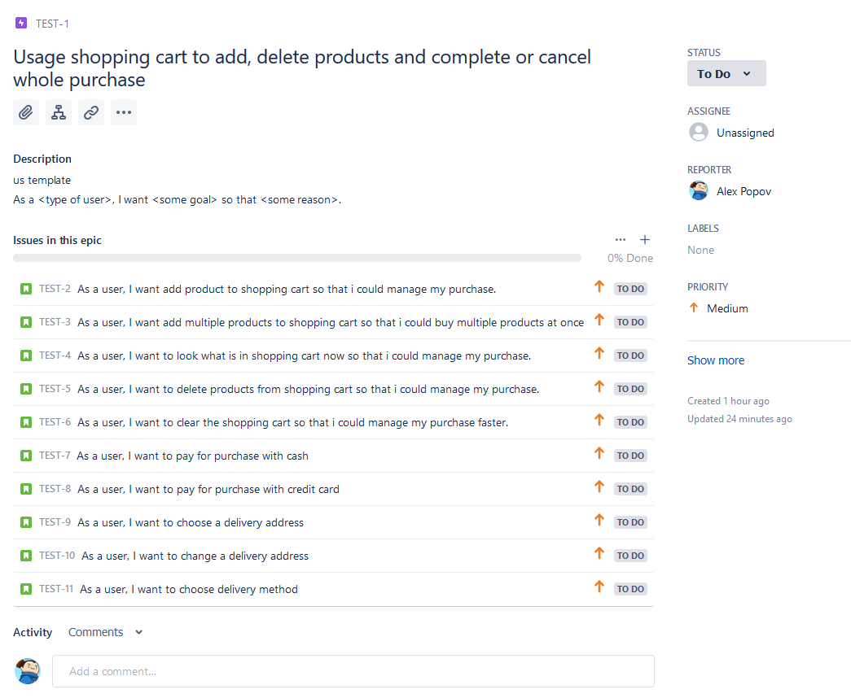

Epic 2 user profile



Epic 3 Products catalogue



Break user stories to technical tasks inside one epic

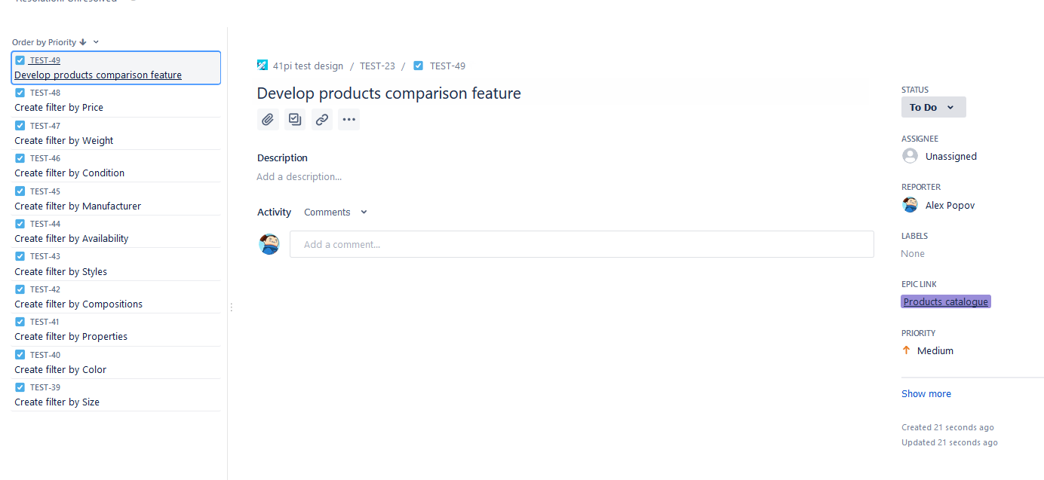

Bug reports http://prestashop.qatestlab.com.ua/en/

1

Summary: scaling web page moves elements across page

Preconditions: none

Steps to reproduce:

1. visit <http://prestashop.qatestlab.com.ua/en/>

2. scale web page to min scale

Expected result: Elements scale evenly, do not disappear outside screen boundaries

Actual result: Main block stays at left side, while other block are in middle

Post conditions: none

Environment: windows 10, 64x, mozilla firefox 67.0 (64-bit)

2

Add fist product to cart. Go to cart page. Cart product counter at right top side says you have 2 products instead of 1

3

Try delete product from cart on card page. Hover mouse on cart Dropdown menu. It shows a product with 0 amount. Reloading page will delete from dropdown

4

Precondition: deleted product from cart

Add another product, not same as deleted. Check shopping cart. Besides that there is an added product, there is the product with 0 amount that was deleted

5

Localization working only for few things

6

Use a sorting dropdown. Page is scrolled down to products. Scroll back to top. Project counter above view buttons is half covered with banner

7

Use list view on products. Products’ description overflows under buttons

8

Use “more” button on product. Quantity can be set to negative amount

9

Registration form requires password, but no \* after Password label

10

Address adding form. In both phone input fields can be entered latin symbol as valid